***Summary Report***

*Round Table Meet on*

***“Management of Moderate to Severe Infective Exacerbations of Chronic Bronchitis in Outpatient Settings”***

* ***Venue: Hotel Taj Corbett, Jim Corbett***
* ***Date: 25th May’19***

***Scientific Chairpersons/Cordinator:***

*Dr Agam Vora*

*Dr S.K.Katiyar*

*Dr Suryakant Tripathy*

*Attendees:*

*Dr. S.K.PATHAK*

*Dr. SURYAKANT TRIPATHI*

*Dr. ANKIT DESHWAL*

*Dr. HARISH VAISHNOV*

*Dr. BRAJESH PRAJAPATI*

*Dr. MANOJ AGRAWAL*

*Dr. D.P.MISHRA*

*Dr. T.K.AGRAWAL*

*Dr. ASHISH JAISWAL*

*Dr. SANJEEV SUMAN*

*Dr. AWADESH VASHISTH*

*Dr. MANDEEP SINGH*

*Dr. GURAUNAK SINGH*

*Dr. K P SHIRVASTAVA*

*Dr. MANISH KUMAR*

*Dr. PUNEET AGARWAL*

*Dr. ANUPAM SINGH*

*Dr. R A S KUSHWAHA*

*Dr. ASHOK GUPTA*

*Dr. AMIT AGRAWAL*

*Dr. RAJAT AGRAWAL*

*Dr. HARENDRA YADAV*

*Dr. NEERAJ KUMAR*

*Dr. GUPREET NARULA*

*Dr. VEEROTTAM TOMAR*

***Objective:***

*To understand the infection pattern in Moderate to Severe AECB & COPD and also to get an insight about positioning Cefditoren in management of infectious AECB & COPD in OPD.*

*Special focus was given on 2 parameters:*

1. *Time Interval to Next Exacerbation*
2. *Eradication of Infection involving : Klebsiella, Streptococcus and other Respiratory pathogens*

***The Program Flow***

|  |  |  |
| --- | --- | --- |
| *25th May’19* | | |
| *Check in from 12 noon onwards* | | |
| ***Time*** | ***Topic*** | ***Speaker*** |
| *7:30 pm – 7:35 pm* | *Welcome* | *Dr Agam Vora* |
| *7:35 pm – 7:40 pm* | *Corporate Welcome* | *Mr. Alhad Mahajani* |
| *7:40 pm – 8:10 pm* | *Overview of AECB/COPD, Current issues and challenges* | *Dr S.K.Katiyar* |
| *8:10pm – 8: 40pm* | *Infectious AECB/COPD & Choice of antibiotics* | *Dr Agam Vora* |
| *8:40pm – 9: 10pm* | *Cefditoren : A newer Antibiotic in infectious AECB/COPD* |  |
| *9: 10pm onwards* | *“Breath Free” : A Grand Get-together* | |

*Details*

*A warm welcome extended by Zuventus to all the invitees amidst the amusing natural beauty of Jim Corbett at Hotel Taj Corbett on 25th May’19.*

*The evening of 25th May was made a special one by the brainstorming Round Table Discussion on “Management of Moderate to Severe Infective Exacerbations of Chronic Bronchitis in Outpatient Settings”.*

*The scientific session started sharp at 07:30 PM with a warm welcome by Dr Agam Vora on behalf of Academy of Advance Medical Education and Mr. Alhad Mahajani (VP-Marketing) on behalf of Zuventus.*

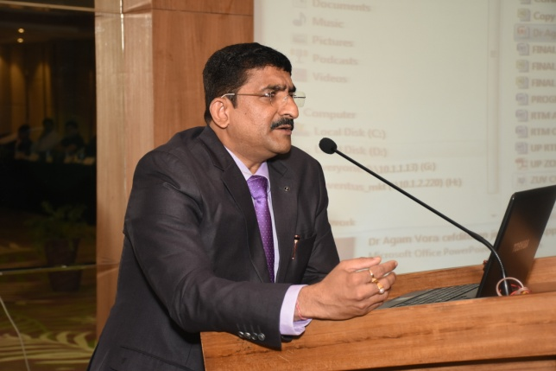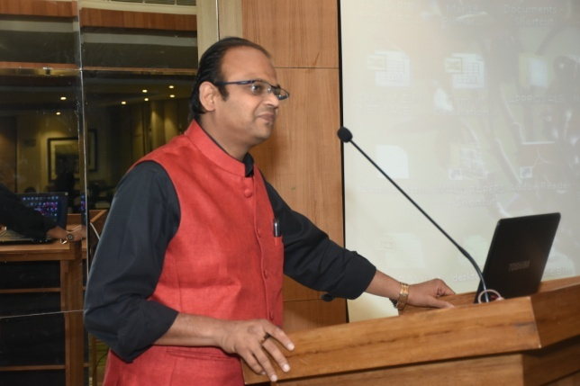

*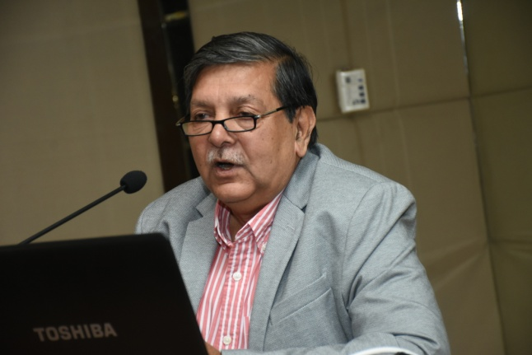Scientific Chair, Dr S.K. Katiyar presented an overview of the subject and appropriateness of Cefditoren in AECB & COPD following which Dr Agam Vora put forward the current issues in managing infectious AECB & COPD in OPD and Choice of Antibiotic with special focus on Cefditoren as a choice of antibiotic.*

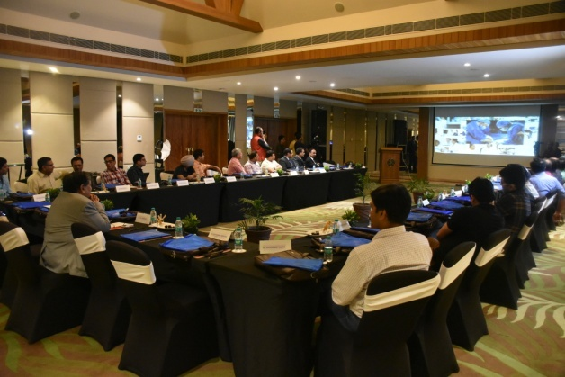

***POINTS DISCUSSED IN ROUND TABLE MEET.***

1. *Antibiotics must be used rationally in AECB/COPD cases. In most of the cases Antibiotics are required.*
2. *Fluoroquinolones should not be used in AECB/COPD or any RTI cases (except in case of Beta lactam/Cephalosporin allergic patients).*
3. *Macrolides are not effective against Streptococci, hence, not a choice in AECB/COPD.*
4. *During panel discussion, emphasis was given on preferably not to use Levofloxacin in respiratory infections with exception of beta lactam allergy. Fatal Cardiac adverse effects associated with Levofloxacin & Severe hypokalemia with Azithromycin limits use of these antibiotics in co-morbid conditions.*
5. *Cephalosporins are the best choice for AECB/COPD cases and looking at the wider spectrum and efficacy, wider beta lactamase stability – Cefditoren can be the appropriate choice of antibiotic in AECB/COPD.*
6. *Depending on the severity of Infection Cefditoren can be used as 200 mg to 400 mg BID for 10 days in AECB/COPD.*

*Overall positive opinion about Cefditoren and the house agreed on the point that Levofloxacin should not be used in RTI including AECB & COPD & Azithromycin has no activity against S.pneumoniae*

*---------------------------------End of Report-----------------------------------------------*